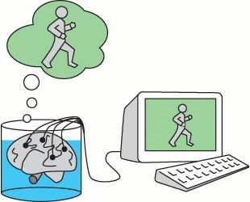
What if you are just a brain in a jar?
A big part of this course in Critical Thinking is looking at how we know something. One famous thought experiment is Hilary Putnam’s “Brain in a jar problem”, which he discussed in the 1950s.
The question Putnam asked and discussed was: How do we know that we are not merely brains in a jar whose thoughts are controlled by a supersonic computer. All our ideas, thoughts, and imaginations of the world surrounding us are just made up by the computer and sent to our brain via wires. How can you tell that you are not living under an illusion and that your brain is not stimulated by a computer to think that your life is real?
This course in critical thinking is intended to not only whet your curiosity regarding questions which are difficult to answer or which do not possess a clear-cut answer at all, but it is also intended to practice counterintuitive thinking. Classroom discussions in the English language, collaborative as well as individual approaches to controversial issues will be in the focus of this course.
Additionally, some of the following problems or topics will be discussed:
- Why do we start stereotyping the moment we see a face?
- What knowledge are conspiracy theories based on?
- To what extent can we trust our instincts and when should we start questioning them?
- Why are all modern maps of the world the same way up and what effect does this have on how we see ourselves and others?
If these possible topics appeal to you, why not register for a course like Critical Thinking?
The course will meet in two weekly lessons. There will be no written exams; however, students are expected to contribute actively in classroom discussions and to present their ideas in presentations. The classroom language is English, but you do not have to be a language “expert”. The idea is that you improve your language skills and your ability to speak once you join our discussions and read the assigned texts.
For further information do not hesitate to contact your Critical Thinking teacher!
S. Detering

